
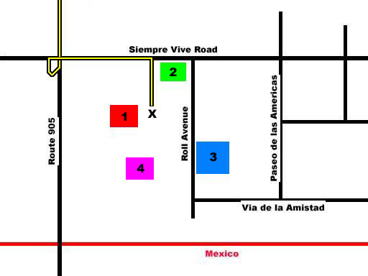
A: Take I-15 South towards
downtown San Diego
a1 - Stay LEFT on I-15 at the
CA 163 split
a2 - Pass the I-8 interchange
B: Merge onto I-805 South
Travel approx. 12 miles
C: Merge onto CA 905 East
Travel approx. 6 miles
c1 - Pass first clock tower on right
c2 - Pass Brown Field on left
c3 - Look for second clock tower
on right at Otay Crossing
Self-Storage
c4- Turn right at traffic light
towards Otay border crossing
D: Take next exit - Siempre Viva Road
Last exit before border crossing
d1 - Go left at the fork in the ramp
E: Turn RIGHT at light at end of ramp
Cross the overpass
F: Turn RIGHT into McDonalds parking lot
(adjacent to gas station)
Driving directions to Otay Mesa border crossing
from areas north of the MCAS Miramar
Rendezvous in the McDonalds
parking lotlocated at the intersection of
Siempre Viva Road and Roll Avenue
Interstate 8
I-15
905
163
805
805
Brown
Field
MCAS
Miramar
I-15
I-15
A
B
C
McDonalds
Parking Options – Remember – Park at your own risk.
Street parking (free) is available on Roll Avenue, Via de la Amistad, and other neighboring streets.
1 – McDonalds – Posted signs warn that all day parking in the McDonalds lot is NOT permitted
and violators will be towed
2 – Gas station – all day parking available for a fee in their adjoining lot. Pay at cashier.
3 – Public parking lot – Cost between $5 - $10 per day
4 – IHOP – Eat breakfast at IHOP and park in their lot all day for free. Check at the restaurant to
confirm their current policy and to obtain a temporary parking permit.
November 2007
a1
a2
c1
c2
c3
E
D
F
⁄
d1
⁄
⁄
Pedestrian Border Crossing
Automobile
Border Crossing
Build A Miracle
x

Siempre Viva Road
c4
IHOP
Gas
Parking
Lot

